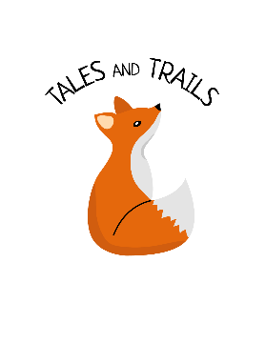
Confidentiality Policy
Tales and Trails Forest School
Last review: October 2019

Tales and Trails aims to keep all children safe.
We aim to ensure that all parents and carers can share their information in the confidence that it will only be used to enhance the welfare of their children. Parents have ready access to the files and records of their own children but do not have access to information about any other child. Staff will not discuss personal information given by parents with other members of staff, except where it affects planning for the child’s needs. Personal information about children is kept securely. Issues to do with the appointment of volunteers remain confidential to the people directly involved with making personnel decisions. Parents’ permission will be sought before photographs are taken of children, either as individuals or in groups. Permission is normally given in the Child Registration Form. All the undertakings above are subject to the paramount commitment of Forest school, which is to the safety and well-being of the child.

