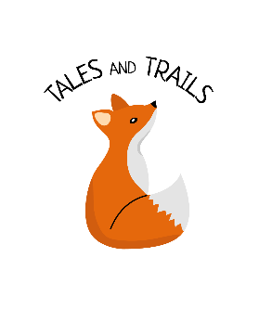
Food and Drink Policy
Tales and Trails Forest School
Last review: October 2019

Tales and Trails regards snack and meal times as an important part of the session/day. Eating represents a social time for children and adults and helps children to learn about healthy eating. If food is provided by Tales and Trails, we aim to provide nutritious food, which meets the children’s individual dietary needs. Before a child attends their first session, we find out from parents their children’s dietary needs, including any allergies through the Child Registration Form. All staff and volunteers are fully informed about individual children’s dietary needs. Children receive only food and drink which is consistent with their dietary needs and their parents’ wishes. Through discussion with parents and educational establishment staff and research reading by staff, we obtain information about the dietary rules of the religious groups, to which children and their parents belong, and of vegetarians and vegans, and about food allergies. We take account of this information in the provision of food and drinks. We have fresh drinking water constantly available for the children. We inform the children about how to obtain the water and that they can ask for water at any time during the session/day.

