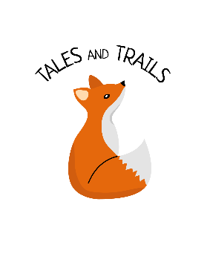
Health and Safety Policy
Tales and Trails Forest School
Last review: October 2019

Statement of Aims
It is a matter of principle that Project Connect personnel respect the policies of the organisation. However, there are particular issues relating to the woodland, the specialist tools used there and with lighting fires which are not included in the standard Health and Safety policy and for which this document is an addendum. Forest school sessions offer learning opportunities for children and young people. Part of their purpose is to encourage participants to face new challenges and to learn to take reasonable risks. In order to do that safely, the adults involved must know their role and ensure that the necessary risk assessments are carried out regularly and thoroughly. Risks can rarely be eliminated entirely, but they can be reduced to a minimum without unduly limiting opportunities for children to explore and learn.
Objectives of the document.
• To identify the roles of those involved in Forest Schools, with respect to Health & Safety.
• To identify safety procedures so that they can be carried out effectively and without difficulty.
• To identify suitable and sufficient risk assessment processes to ensure that risks are adequately controlled.
• To develop effective communication systems throughout the setting.
• To ensure that all those involved in Forest School are aware of all relevant Health & Safety documents.
• To develop effective inspection/monitoring procedures to ensure compliance with Local Authority Health & Safety requirements.

