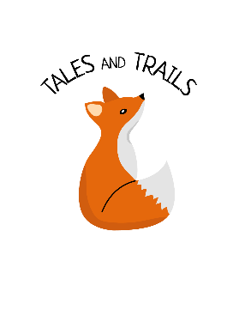
Behaviour Policy
Tales and Trails Forest School
Last review: October 2019

Tales and Trails aims to keep all children safe.
Tales and Trails may use the following tools children during sessions:
• Bow Saw
• Hand drill
• Clamps
• Wooden mallets
• Fixed blade knife
• Loppers
• Bill hook
Tools are used with children with a minimum ratio of 1:4 supervision. The Forest School Leader and Forest School Assistant are responsible for overseeing safe use and maintenance of all tools.
A list of the items stored in each box is attached to each tool box and used as check lists to ensure that all items are returned safely at the end of each session. The Tool Boxes contains sharp tools such as knives and axes is kept locked at all times when not in use.
The Forest School Leader and Forest School Assistant wear steel toe-capped boots for all Forest School sessions.
Appropriate gloves and hats are also available as Personal Protection Equipment when needed.
Activity Risk/Benefit Assessments are completed for all activities involving the use of tools.

